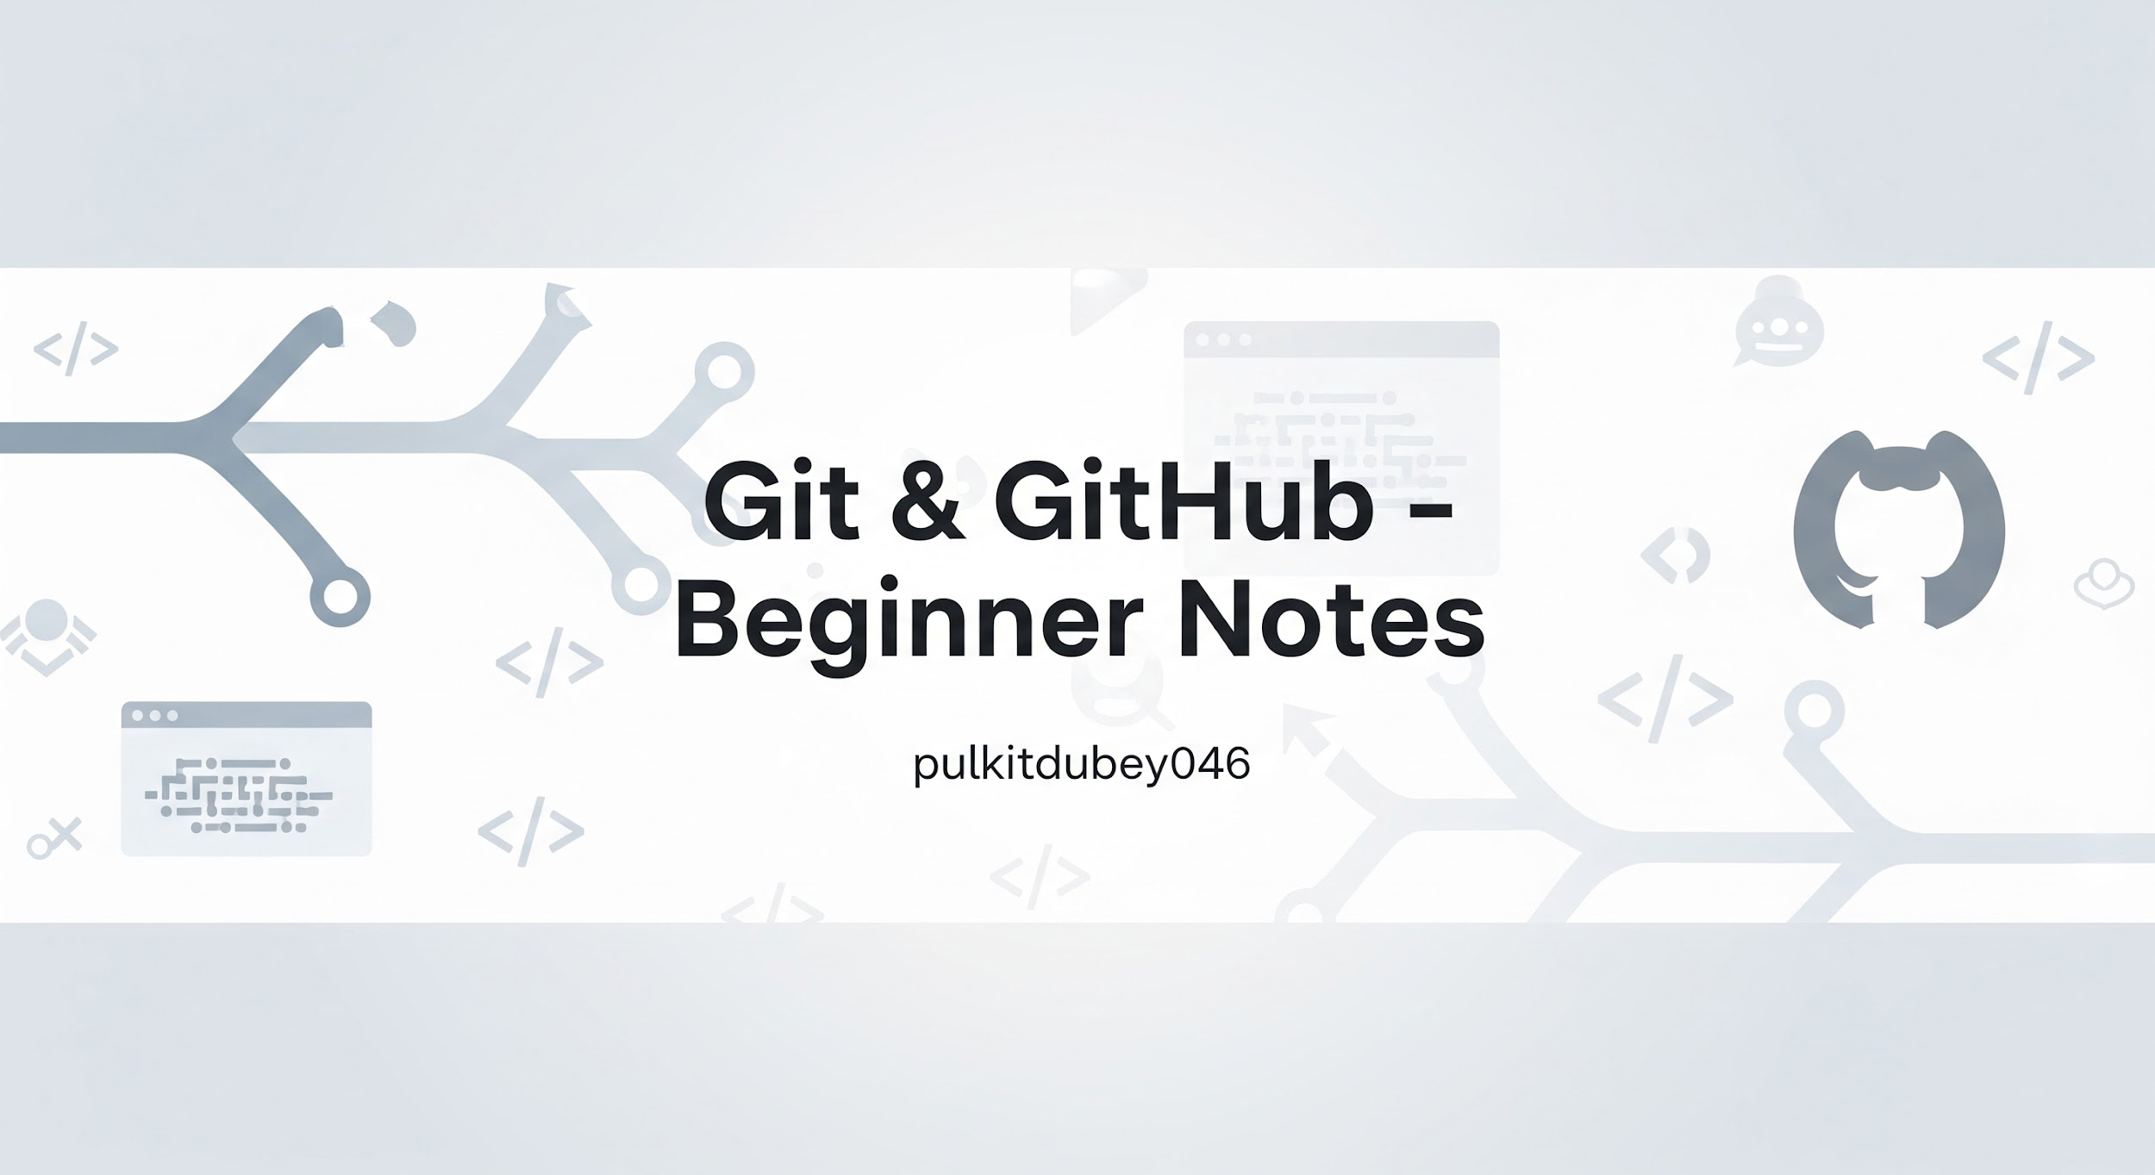
These notes are designed for absolute beginners. They follow a safe, logical order and explain every concept before using it. No prior Git knowledge is assumed.

1. What is Git?
Git is a version control system. It helps you track changes in files over time. Instead of manually saving multiple versions of a project, Git records snapshots of your work so you can move backward or forward safely. Git is used mainly for source code, but it can track any type of file.

2. Why Use Git?
Git allows you to:

- Track changes to files
- Recover older versions of a project
- Experiment safely without breaking working code
- Collaborate with other developers

3. Installing Git
Git must be installed on your system before use. After installation, confirm it works by running:

git --version

4. Basic Git Concepts
Concept | Description
Repository (repo) | A folder tracked by Git.
Commit | A saved snapshot of your project.
Working Directory | Your actual files.
Staging Area | Files prepared for commit.
Branch | A separate line of development.

5. Creating a Git Repository
To start tracking a project with Git, navigate into the folder and run:

git init

This creates a hidden .git folder that stores all tracking data.

6. Checking Repository Status
Use the following command to see file states:

git status

It shows untracked files, modified files, and staged files.

7. Tracking Files
Add files to the staging area using:

git add filename

To add all files:

git add .

8. Committing Changes
Save staged changes using:

git commit -m "meaningful message"

Commits should describe what changed, not how.

9. Viewing Commit History
To see past commits:

git log

10. Branching Basics
Branches let you work on features without affecting main code.

- Create a branch: git branch branch-name
- Switch branch: git checkout branch-name
- Create and switch: git checkout -b branch-name

11. Merging Branches
To combine changes from one branch into another:

git merge branch-name

12. Undoing Mistakes Safely
- Undo unstaged changes: git checkout -- filename
- Unstage a file: git reset filename

13. Remote Repositories
Remote repositories live online (e.g., GitHub).

Add remote: git remote add origin URL

14. Pushing Code
Upload commits to remote repository:

git push origin branch-name

15. Pulling Changes
Download changes from remote:

git pull origin branch-name

16. Basic Git Workflow
- Edit files
- git status
- git add
- git commit
- git push

17. Best Practices for Beginners
- Commit small, logical changes
- Write clear commit messages
- Pull before pushing
- Use branches for experiments

